**calc.java**

package calc;

public class calc {

public int addition(int a, int b)

{

return a+b;

}

public int subtarct(int a, int b)

{

return a-b;

}

public int multiplication(int a, int b)

{

return a*b;

}

public int division(int a, int b)

{

return a/b;

}

}

**calc.wsdl:**

<?xml version="1.0" encoding="UTF-8"?>

<wsdl:definitions targetNamespace="http://calc" xmlns:apachesoap="http://xml.apache.org/xml-soap" xmlns:impl="http://calc" xmlns:intf="http://calc" xmlns:wsdl="http://schemas.xmlsoap.org/wsdl/" xmlns:wsdlsoap="http://schemas.xmlsoap.org/wsdl/soap/" xmlns:xsd="http://www.w3.org/2001/XMLSchema">

<!--WSDL created by Apache Axis version: 1.4

Built on Apr 22, 2006 (06:55:48 PDT)-->

<wsdl:types>

<schema elementFormDefault="qualified" targetNamespace="http://calc" xmlns="http://www.w3.org/2001/XMLSchema">

<element name="addition">

<complexType>

<sequence>

<element name="a" type="xsd:int"/>

<element name="b" type="xsd:int"/>

</sequence>

</complexType>

</element>

<element name="additionResponse">

<complexType>

<sequence>

<element name="additionReturn" type="xsd:int"/>

</sequence>

</complexType>

</element>

<element name="multiplication">

<complexType>

<sequence>

<element name="a" type="xsd:int"/>

<element name="b" type="xsd:int"/>

</sequence>

</complexType>

</element>

<element name="multiplicationResponse">

<complexType>

<sequence>

<element name="multiplicationReturn" type="xsd:int"/>

</sequence>

</complexType>

</element>

<element name="division">

<complexType>

<sequence>

<element name="a" type="xsd:int"/>

<element name="b" type="xsd:int"/>

</sequence>

</complexType>

</element>

<element name="divisionResponse">

<complexType>

<sequence>

<element name="divisionReturn" type="xsd:int"/>

</sequence>

</complexType>

</element>

<element name="subtarct">

<complexType>

<sequence>

<element name="a" type="xsd:int"/>

<element name="b" type="xsd:int"/>

</sequence>

</complexType>

</element>

<element name="subtarctResponse">

<complexType>

<sequence>

<element name="subtarctReturn" type="xsd:int"/>

</sequence>

</complexType>

</element>

</schema>

</wsdl:types>

<wsdl:message name="multiplicationRequest">

<wsdl:part element="impl:multiplication" name="parameters">

</wsdl:part>

</wsdl:message>

<wsdl:message name="subtarctRequest">

<wsdl:part element="impl:subtarct" name="parameters">

</wsdl:part>

</wsdl:message>

<wsdl:message name="subtarctResponse">

<wsdl:part element="impl:subtarctResponse" name="parameters">

</wsdl:part>

</wsdl:message>

<wsdl:message name="divisionResponse">

<wsdl:part element="impl:divisionResponse" name="parameters">

</wsdl:part>

</wsdl:message>

<wsdl:message name="additionRequest">

<wsdl:part element="impl:addition" name="parameters">

</wsdl:part>

</wsdl:message>

<wsdl:message name="additionResponse">

<wsdl:part element="impl:additionResponse" name="parameters">

</wsdl:part>

</wsdl:message>

<wsdl:message name="multiplicationResponse">

<wsdl:part element="impl:multiplicationResponse" name="parameters">

</wsdl:part>

</wsdl:message>

<wsdl:message name="divisionRequest">

<wsdl:part element="impl:division" name="parameters">

</wsdl:part>

</wsdl:message>

<wsdl:portType name="calc">

<wsdl:operation name="addition">

<wsdl:input message="impl:additionRequest" name="additionRequest">

</wsdl:input>

<wsdl:output message="impl:additionResponse" name="additionResponse">

</wsdl:output>

</wsdl:operation>

<wsdl:operation name="multiplication">

<wsdl:input message="impl:multiplicationRequest" name="multiplicationRequest">

</wsdl:input>

<wsdl:output message="impl:multiplicationResponse" name="multiplicationResponse">

</wsdl:output>

</wsdl:operation>

<wsdl:operation name="division">

<wsdl:input message="impl:divisionRequest" name="divisionRequest">

</wsdl:input>

<wsdl:output message="impl:divisionResponse" name="divisionResponse">

</wsdl:output>

</wsdl:operation>

<wsdl:operation name="subtarct">

<wsdl:input message="impl:subtarctRequest" name="subtarctRequest">

</wsdl:input>

<wsdl:output message="impl:subtarctResponse" name="subtarctResponse">

</wsdl:output>

</wsdl:operation>

</wsdl:portType>

<wsdl:binding name="calcSoapBinding" type="impl:calc">

<wsdlsoap:binding style="document" transport="http://schemas.xmlsoap.org/soap/http"/>

<wsdl:operation name="addition">

<wsdlsoap:operation soapAction=""/>

<wsdl:input name="additionRequest">

<wsdlsoap:body use="literal"/>

</wsdl:input>

<wsdl:output name="additionResponse">

<wsdlsoap:body use="literal"/>

</wsdl:output>

</wsdl:operation>

<wsdl:operation name="multiplication">

<wsdlsoap:operation soapAction=""/>

<wsdl:input name="multiplicationRequest">

<wsdlsoap:body use="literal"/>

</wsdl:input>

<wsdl:output name="multiplicationResponse">

<wsdlsoap:body use="literal"/>

</wsdl:output>

</wsdl:operation>

<wsdl:operation name="division">

<wsdlsoap:operation soapAction=""/>

<wsdl:input name="divisionRequest">

<wsdlsoap:body use="literal"/>

</wsdl:input>

<wsdl:output name="divisionResponse">

<wsdlsoap:body use="literal"/>

</wsdl:output>

</wsdl:operation>

<wsdl:operation name="subtarct">

<wsdlsoap:operation soapAction=""/>

<wsdl:input name="subtarctRequest">

<wsdlsoap:body use="literal"/>

</wsdl:input>

<wsdl:output name="subtarctResponse">

<wsdlsoap:body use="literal"/>

</wsdl:output>

</wsdl:operation>

</wsdl:binding>

<wsdl:service name="calcService">

<wsdl:port binding="impl:calcSoapBinding" name="calc">

<wsdlsoap:address location="http://localhost:8081/Calc/services/calc"/>

</wsdl:port>

</wsdl:service>

</wsdl:definitions>

**OUTPUT:**

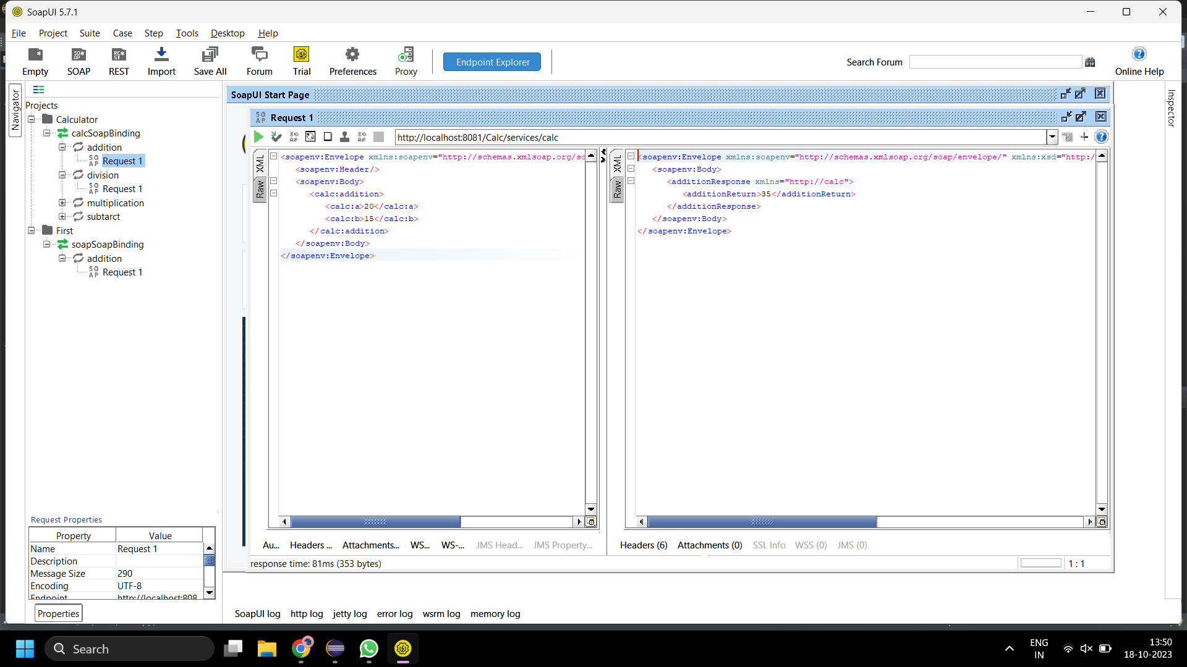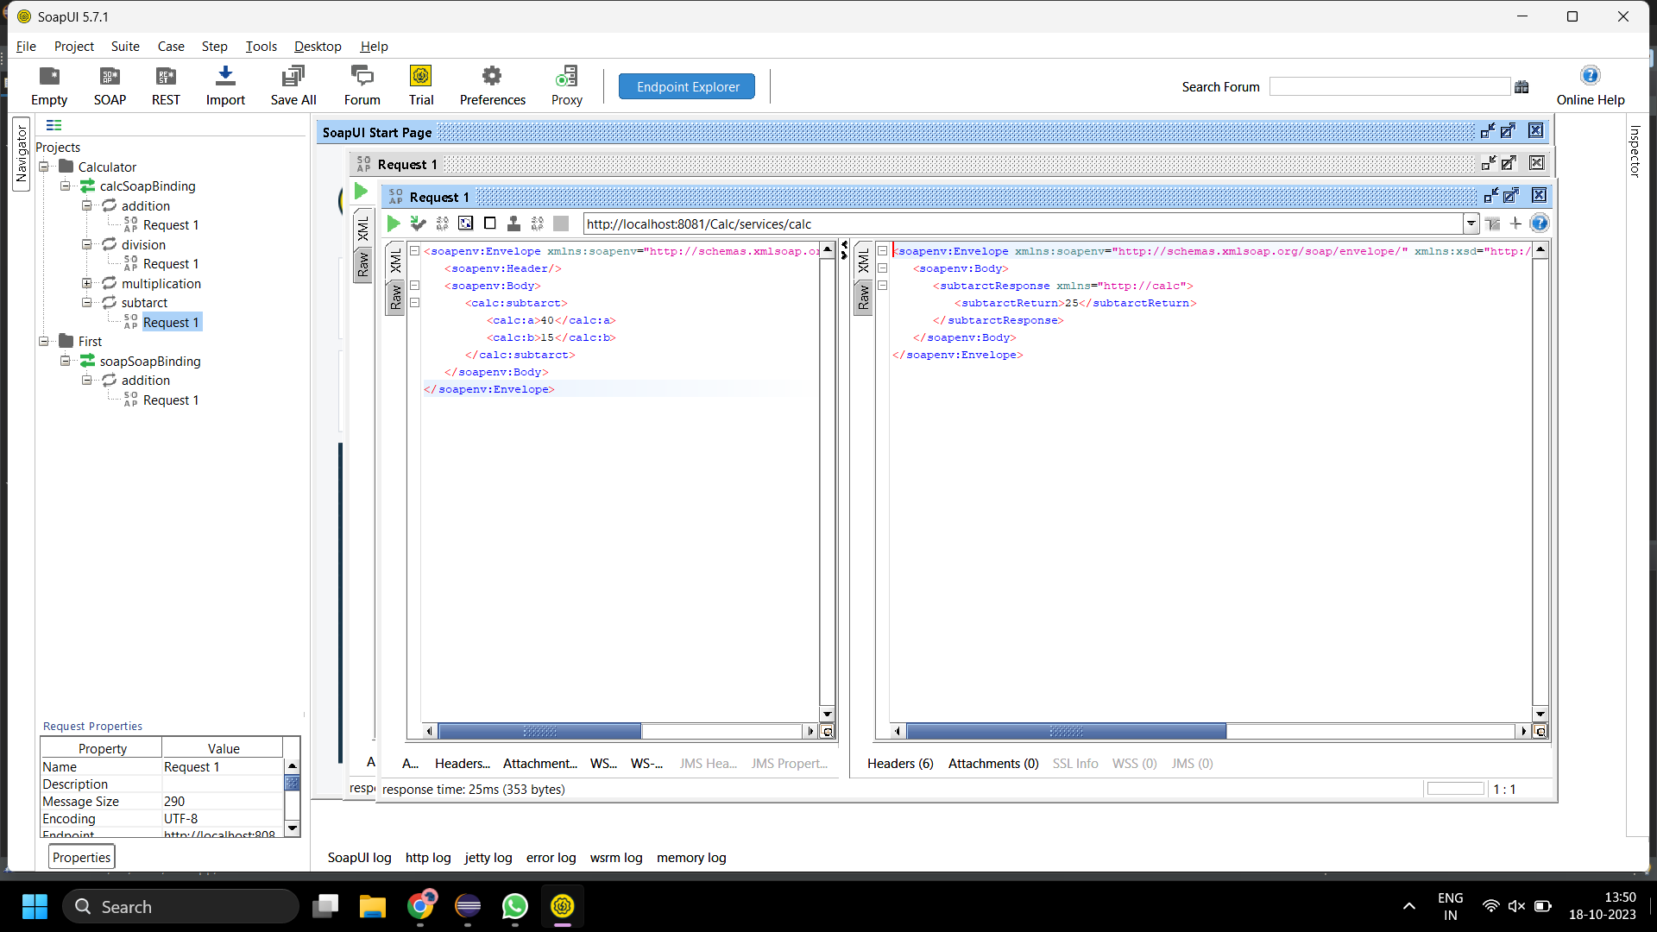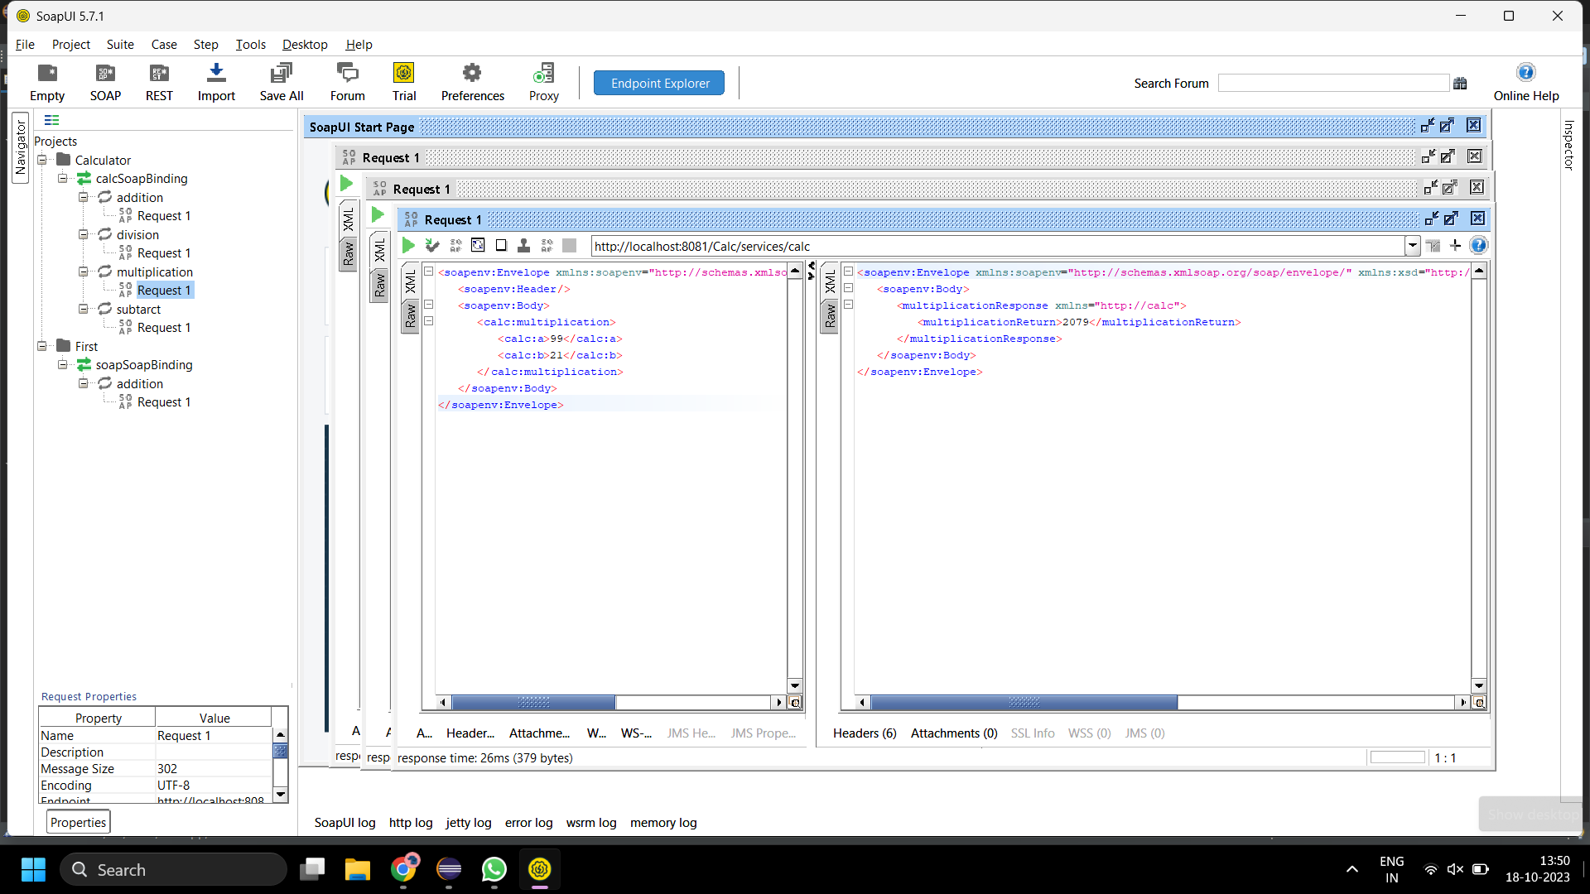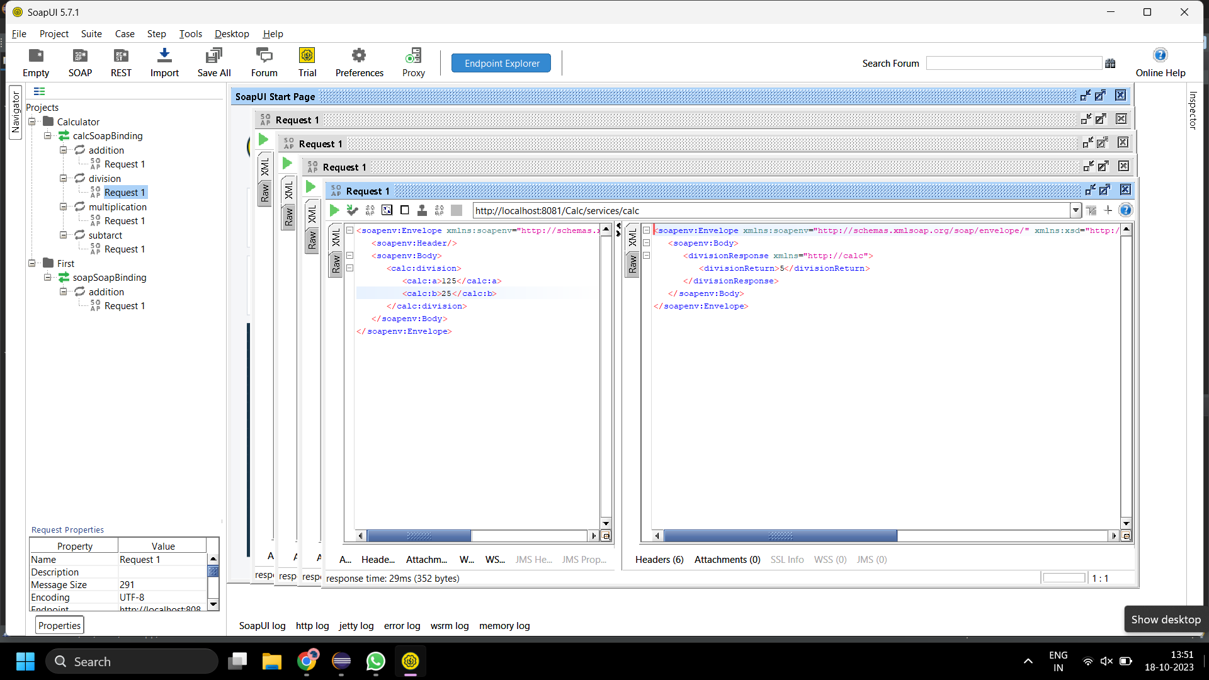

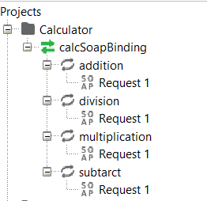

**temp.java:**

package temp;

public class temp {

public int toFahrenheit(int temp)

{

return (temp*9/5)+32;

}

public int toCelsius(int temp)

{

return (temp-32)*5/9;

}

}

**temp.wsdl:**

<?xml version="1.0" encoding="UTF-8"?>

<wsdl:definitions targetNamespace="http://temp" xmlns:apachesoap="http://xml.apache.org/xml-soap" xmlns:impl="http://temp" xmlns:intf="http://temp" xmlns:wsdl="http://schemas.xmlsoap.org/wsdl/" xmlns:wsdlsoap="http://schemas.xmlsoap.org/wsdl/soap/" xmlns:xsd="http://www.w3.org/2001/XMLSchema">

<!--WSDL created by Apache Axis version: 1.4

Built on Apr 22, 2006 (06:55:48 PDT)-->

<wsdl:types>

<schema elementFormDefault="qualified" targetNamespace="http://temp" xmlns="http://www.w3.org/2001/XMLSchema">

<element name="toFahrenheit">

<complexType>

<sequence>

<element name="temp" type="xsd:int"/>

</sequence>

</complexType>

</element>

<element name="toFahrenheitResponse">

<complexType>

<sequence>

<element name="toFahrenheitReturn" type="xsd:int"/>

</sequence>

</complexType>

</element>

<element name="toCelsius">

<complexType>

<sequence>

<element name="temp" type="xsd:int"/>

</sequence>

</complexType>

</element>

<element name="toCelsiusResponse">

<complexType>

<sequence>

<element name="toCelsiusReturn" type="xsd:int"/>

</sequence>

</complexType>

</element>

</schema>

</wsdl:types>

<wsdl:message name="toFahrenheitRequest">

<wsdl:part element="impl:toFahrenheit" name="parameters">

</wsdl:part>

</wsdl:message>

<wsdl:message name="toCelsiusResponse">

<wsdl:part element="impl:toCelsiusResponse" name="parameters">

</wsdl:part>

</wsdl:message>

<wsdl:message name="toCelsiusRequest">

<wsdl:part element="impl:toCelsius" name="parameters">

</wsdl:part>

</wsdl:message>

<wsdl:message name="toFahrenheitResponse">

<wsdl:part element="impl:toFahrenheitResponse" name="parameters">

</wsdl:part>

</wsdl:message>

<wsdl:portType name="temp">

<wsdl:operation name="toFahrenheit">

<wsdl:input message="impl:toFahrenheitRequest" name="toFahrenheitRequest">

</wsdl:input>

<wsdl:output message="impl:toFahrenheitResponse" name="toFahrenheitResponse">

</wsdl:output>

</wsdl:operation>

<wsdl:operation name="toCelsius">

<wsdl:input message="impl:toCelsiusRequest" name="toCelsiusRequest">

</wsdl:input>

<wsdl:output message="impl:toCelsiusResponse" name="toCelsiusResponse">

</wsdl:output>

</wsdl:operation>

</wsdl:portType>

<wsdl:binding name="tempSoapBinding" type="impl:temp">

<wsdlsoap:binding style="document" transport="http://schemas.xmlsoap.org/soap/http"/>

<wsdl:operation name="toFahrenheit">

<wsdlsoap:operation soapAction=""/>

<wsdl:input name="toFahrenheitRequest">

<wsdlsoap:body use="literal"/>

</wsdl:input>

<wsdl:output name="toFahrenheitResponse">

<wsdlsoap:body use="literal"/>

</wsdl:output>

</wsdl:operation>

<wsdl:operation name="toCelsius">

<wsdlsoap:operation soapAction=""/>

<wsdl:input name="toCelsiusRequest">

<wsdlsoap:body use="literal"/>

</wsdl:input>

<wsdl:output name="toCelsiusResponse">

<wsdlsoap:body use="literal"/>

</wsdl:output>

</wsdl:operation>

</wsdl:binding>

<wsdl:service name="tempService">

<wsdl:port binding="impl:tempSoapBinding" name="temp">

<wsdlsoap:address location="http://localhost:8081/Temp/services/temp"/>

</wsdl:port>

</wsdl:service>

</wsdl:definitions>

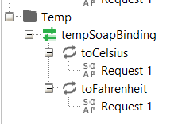

**OUTPUT:**

